Resume Overview

Reda Mustafa
Riyadh, Saudi Arabia
✉ reddbamma@gmail.com | ☎ +966 53 577 9942 | LinkedIn

Profile Summary
Portfolio/Program Director | Architect | Building Services Professional
Results-driven leader with 25+ years of experience in GCC and Africa regions, specializing in Project, Design, and Construction Management across diverse sectors:
- Mega Real Estate | Banking | Commercial | Healthcare | Hospitality | Education | Industrial | Airports | Prisons | Religious & Iconic Buildings
Core Expertise:
- End-to-end project delivery (consultant, contractor, and client-side)
- Multi-disciplinary team leadership & stakeholder management
- Strategic planning, contract administration (FIDIC), and procurement
- Agile problem-solving, cost control, and risk mitigation
Leadership Approach:
Technical expert with a collaborative leadership style, adept at coaching teams, resolving cross-functional challenges, and driving high-value programs.

Key Saudi Arabia Experience
- Diriyah Gate Company (Sep 2023–Present) – Project Director for Ritz Carlton Residences (1B SAR) & King Salman Knowledge District (8B SAR portfolio).
- Arcadis (2017–2023) – Program/Design Director for Al Rajhi Bank HQ Tower (1.5B SAR), Tier 4 Data Centre (400M SAR), and NCD District (2.5B SAR).
- YMCO/ACE Contracting (2011–2014) – Delivered 650M SAR in projects (e.g., Saudi Aviation Institute, Care Centers, Cold Stores).

Professional Experience
Diriyah Gate Company Limited
Project Director | Sep 2023–Present
- Lead 1B SAR Ritz Carlton Residences (106 villas) and 8B SAR King Salman Knowledge District (11 assets).
- Oversee Tier 1 design consultants (Gensler, Foster + Partners, Zaha Hadid) and contractors.
- Manage procurement, FIDIC contracts, EOT claims, and stakeholder reporting.
Project Director (Secondment) | Apr–Aug 2023
- Spearheaded district-wide PMCM procurement and cost-plan governance.

Arcadis
Director | Associate Director | 2019–2023
- Program-managed 2.7B SAR Al Rajhi Bank projects (HQ Tower, Data Centre).
- Established KSA market strategies, led bid evaluations, and mentored teams.
Program/Senior Project Manager | 2016–2019
- Delivered Tier 4 Data Centre (400M SAR) and high-rise tower, ensuring on-time, on-budget completion.
Senior Design Manager | 2014–2017
- Led architectural design, value engineering, and HSE compliance for Al Rajhi HQ Tower.
Prior Roles
- YMCO (2012–2014): Managed 650M SAR portfolio (prisons, aviation, tourism colleges).
- ACE Contracting (2011–2012): Executed precast concrete and healthcare projects.
- KUDAL/Brothers Integrated Solutions (2009–2011): Delivered government and commercial builds (Sudan).
- Concrete Engineering/ETA Electric (2005–2009): Procurement and airport terminal supervision.

Education & Certifications
(Include degrees, PMP, RIBA, or other relevant credentials if applicable.)
Skills
Project Lifecycle Management | FIDIC Contracts | Stakeholder Engagement | Design Coordination | Budgeting & Cost Control | Team Leadership

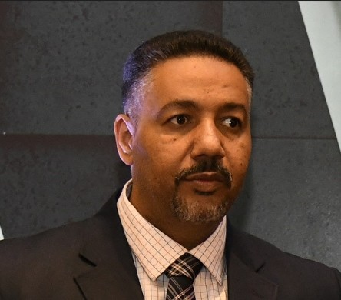

Reda Mustafa – Detailed Experience
Riyadh, Saudi Arabia

 reddbamma@gmail.com 966535779942  linkedin.com/in/reda-mustafa

Profile Summary

A Portfolio/Programme Director and Architect; Building Services professional with more than 25 years of experience (GCC & Africa Regions) working in Client, Consultant and Contractor environments in multiple trades including Project Management, Design management and Construction Management covering all major market sectors including, Mega Real Estate Developments Banking corporations, commercial, healthcare, hospitality, education, industrial, manufacturing, sports centers, airports, Prisons and recreational centers, religious, iconic and signature buildings, mixed use developments and specialist bespoke buildings.
CORE SKILLS
•Team leadership
•Strategy and Agile management
•Portfolio, Programme & Project Management
•Problem solving and analytical thinking
•Contract Management
•Value Engineering and Technical Advisory
•Strategic Planning and Management
•Resource and Budget Management
• Heritage Projects execution and preservation.
QUALIFICATIONS
• 2000 – B.S.C Honour of
• Architecture and Environmental Planning, Sharq El Nile College.
• International Building Material Forums (UAE, Egypt).
• Advance Leadership Program Diploma (Hult Business School).
• Programme Director Diploma (Arcadis-Oxford)
• Managing and Development of Team members (Arcadis).
• Certified Project Manager level 2 (Arcadis).
• Certified Expert (Saudi Engineering Council).
Certified Engineer (Sudan Council of Engineers).
• DBA (Doctor of Business Administration) Golden Gate University – ongoing. EDC Feb 2027
MEMBERSHIPS
- The American Institute of Architects (AIA) Intl Association.
- Project Management Institute (PMI) Intl Association.
Awards
• 2018 MEED Construction Awards for Sustainability and project value ARB-HQ

Working with teams for both single discipline and multi-discipline project delivery with broad experience of projects of different function and nature with the ability to analyze, problem solve and managing a wide network of stakeholders and building different strategy approaches for programme and project delivery and managing diverse teams in an international context.
Approach and Strength
Team leader with multiple collaboration and leadership skills and a strong technical background with an energetic approach towards challenging projects and roles. Ability to coach and enhance team moral and performance. Strong Contract management, project management, Problem solving, analytical and negotiation skills with an agile approach

A glimpse at KSA Experience:

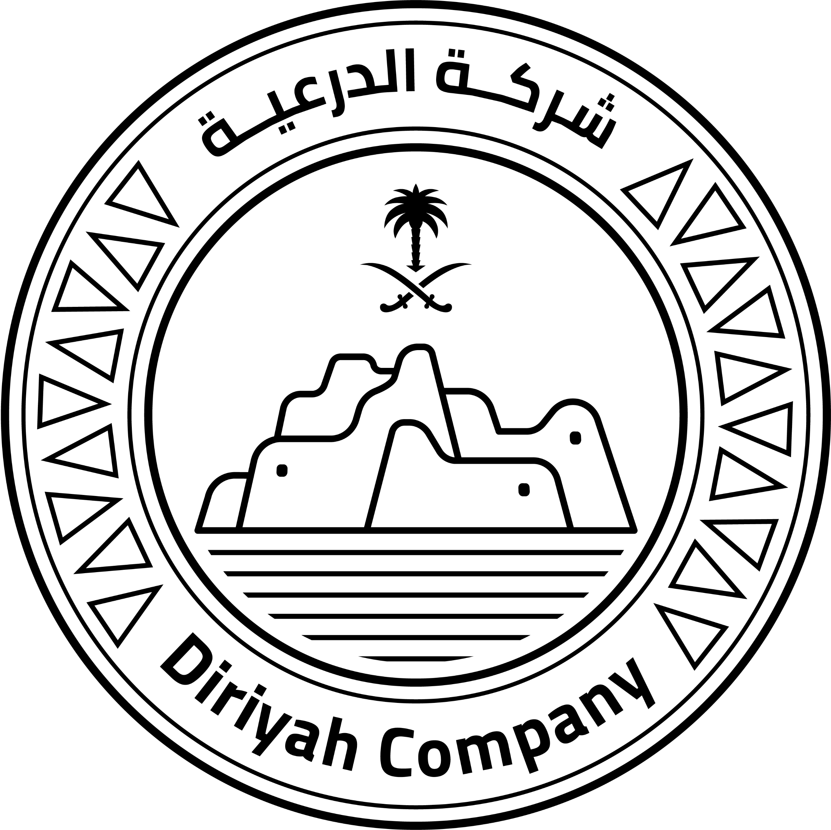 Quriat Cultural District – Ritz Carlton Residences
King Salman Knowledge District - Programme Manager (KSL, P3)
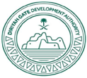 Bujairi Car Park Project
 Al-Rajhi Bank Headquarters Tower,
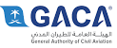
Al-Rajhi Bank Operations & Data Centre– Tier 4,
Saudi Aviation Technical Institute,
 Riyadh Care Center,
 College of Tourism Taif,
 Sharbatly Cold Stores Medina,

Siporex Factory new HQ offices, Aeriated Concrete precast Panels

Detailed Experience

 Diryiah Gate Company Limited

Project Director Sep 2023 – Present

• Managing The Ritz Carlton Residences – 106 signature services villas’ compounds with a value of 1 Billion SAR
• Managing a portfolio of projects in the (King Salman Knowledge District) with a total value of 8 Billion SAR, including construction and design projects:
Ministry of Culture HQ 580 Mn (Gensler Design), KSKD Carpark 540 Mn (WSP Design), House of AlSaud (fosters design), King Slaman University (SOM Design), King Salman Library (Roberto Boufel Design), King Salman Square and Journey of 100 Stories (Bureo Happold Design) Bawabaa Offices (SSH Design), Misk Heritage Institute (Zaha Hadeed Design).
• Managing Multiple contractors across multiple projects
• Managing and overviewing portfolio cost plans, TDC’s, Budgeting,
• Managing Super Plot contractor procurement and conducting technical assessments for bid returns.
• Managing Logistics, Interfaces, and asset coordination.
•Leading the procurement of a district PMCM services to cover all 11 assets in the district.
•Managing various Tier 1 Lead Design Consultants (e.g. RBTA, F+P, BH, ZHA etc.)
•Managing multiple CS Consultants, Contractors across the district.
• Generation of RFPs, PSPR documents, and overall procurement procedures.
• Authoring and preparing tender scopes for multiple bids.
•Administering and managing contracts.
•Overviewing Procurement, Cost and schedules management and steering teams as needed.
•Assessing and evaluation bid submissions and awards.
•Managing and administering FIDIC and modified FIDIC contracts for multiple contractors.
•Managing and administering contracts solutions for EOT assessments and contractual addendums.
•Participating in managing strategic business plans.
•Resolving cross-functional issues at Portfolio and program levels.
•Managing high level management meetings.
• Providing advice and recommendations to the client on work strategy and contractual obligations. providing monthly review reports to KSA MD and OD

Project Director (Secondment) April 2023 – Aug 2023
• Managing a portfolio of projects in the (King Salman Knowledge District) with total value of 8 Billion SAR
• Managing and overviewing portfolio cost plans, TDC’s, Budgeting,
• Managing Logistics, Interfaces, and asset coordination.
•Leading the procurement of a district PMCM services to cover all 11 assets in the district.
•Managing various Tier 1 Lead Design Consultants (e.g. RBTA, F+P, BH, ZHA etc.)
•Managing multiple CS Consultants, Contractors across the district.
• Generation of RFPs, PSPR documents, and overall procurement procedures.
•Administering and managing contracts.
•Overviewing Procurement, Cost and schedules management and steering teams as needed.
•Assessing and evaluation bid submissions and awards.
•Managing and administering FIDIC and modified FIDIC contracts for multiple contractors.
•Managing and administering contracts solutions for EOT assessments and contractual addendums.
•Participating in managing strategic business plans.
•Resolving cross-functional issues at Portfolio and program levels.
•Managing high level management meetings.
• Providing advice and recommendations to the client on work strategy and contractual obligations. providing monthly review reports to KSA MD and OD

Director

Arcadis
Dec 2022 – April 2023
• Managing a Programme of projects within NCD District – DGCL with total value of 2.5 Billion SAR
• Client accounts management,
• Technical reviews for construction bids across multiple projects,
• Managing and developing procurement strategies for large scale projects,
• Authoring and preparing tender scopes for multiple bids.
•Participation in Setting up and execution of company strategies and implementation in market.
•Managing various client accounts.
•Managing multiple international consultants and contractors on multiple deliveries.
•Setting up data base for local market procedures, requirements etc.
•Creating and managing contracts.
•Overviewing Procurement, Cost and schedules management and steering teams as needed.
•Assessing and evaluation bid submissions and awards.
•Managing and administering FIDIC and modified FIDIC contracts for multiple contractors.
•Managing and leading multiple project teams.
•Managing and administering contracts solutions for EOT assessments and contractual addendums.
•Managing cost and commercial teams.
•Monitoring programme schedules and managing client expectations.
•Managing strategic business plans with client and other stakeholders.
•Resolving cross-functional issues at programme level.
•Issuing proposals and invoices for current assignments.
•Exploring new opportunities with client and securing additional assignments.
•Managing high level management meetings.
•Providing advice and recommendations to the client on work strategy and contractual obligations. providing monthly review reports to KSA MD and OD.

Associate Director/ Country Design Lead

Arcadis
Jul 2019 - Present (3 years 2 months +)
Participation in Setting up and execution of company strategies and implementation in market.
•Managing various client accounts.
•Managing multiple international consultants and contractors on multiple deliveries.
•Setting up data base for local market procedures, requirements etc.
•Creation of RFP’s, ITT’s, Task Orders etc.
•Administering and managing contracts.
•Overviewing Procurement, Cost and schedules management and steering teams as needed.
•Assessing and evaluation bid submissions and awards.
•Managing and administering FIDIC and modified FIDIC contracts for multiple contractors.
•Managing and leading both project teams.
•Managing and administering contracts solutions for EOT assessments and contractual addendums.
•Managing cost and commercial teams.
•Monitoring programme schedules and managing client expectations.
•Managing strategic business plans with clients and other stakeholders.
•Resolving cross-functional issues at programme level.
•Issuing proposals and invoices for current assignments.
•Exploring new opportunities with clients and securing additional assignments.
•Managing high level management meetings.
•Providing advice and recommendations to the client on work strategy and contractual obligations. providing monthly review reports to KSA MD and OD.

Program Manager

Arcadis
Nov 2017 - Jun 2019 (1 year 8 months)
Programme Manager (Al Rajhi HQ Tower, Al-Rajhi Operations & Data Centre– Tier 4)-HQ Tower 110 Meters High-rise| Arcadis (Incorporating EC Harris/Hyder Consulting) Programme Value 2.7 billion SAR (Programme Value) Client Name: Al Rajhi Bank - Riyadh KSA
Responsibilities:
•Managing and administering FIDIC and modified FIDIC contracts for multiple contractors.
• Generation of RFPs, PSPR documents, and overall procurement procedures.
•Administering and managing contracts.
•Overviewing Procurement, Cost and schedules management and steering teams as needed.
•Assessing and evaluation bid submissions and awards.
•Managing multiple contractors on high rise buildings (construction, fit-out, MEP, specialist disciplines)
•Managing and leading multiple project teams.
•Managing and administering contracts solutions for EOT assessments and contractual addendums.
•Managing cost and commercial teams.
•Monitoring programme schedules and managing client expectations.
•Managing strategic business plans with client and other stakeholders.
•Resolving cross-functional issues at programme level.
•Issuing proposals and invoices for current assignments.
•Exploring new opportunities with client and securing additional assignments.
•Managing high level management meetings.
•preparing and issuing check point reports on the programme.
•Managing technical consultancy input and assignments in the programme through set deliverables.

Senior Project Manager

Arcadis
Dec 2016 - Feb 2018 (1 year 3 months)
Project Manager (Al-Rajhi Bank Operations & Data Centre– Tier 4)-(Incorporating EC Harris/Hyder Consulting)
Project Value 400 M SAR
Client Name: Al Rajhi Bank - Riyadh KSA Responsibilities:
•Managing Stakeholders expectations, interests, and programme outcomes.
•Managing and leading projects teams.
•Managing and administering contracts.
•Managing co-ordination of partners and working groups engaged in project.
•Detailed project planning and control.
•Managing project deliverables in line with the project plan.
•Resolving cross-functional issues at project level.
•Managing project scope, performance, monitoring and change control.
•Providing status reports to the project sponsor.
•Liaises with, and updates progress to, project Director or client representative.
•Managing project evaluation and dissemination activities.
•Managing consultancy input within the defined budget and scope.
•Definition and management of the Testing and commissioning program.
•Providing regular status reports to PD or CR.
•Agile management & ensuring project delivery.

 Senior Design Manager

Arcadis
Mar 2014 - Jun 2017 (3 years 4 months)
Senior Design Manager/Resident Architect (Al-Rajhi Bank Headquarters Tower)- (Incorporating EC Harris/Hyder Consulting)
Project Value 1.5 billion SAR
Client Name: Al Rajhi Bank - Riyadh KSA Responsibilities:
•Architectural and interior design
•Value Engineering Implementations.
•Reviewing drawings, shop drawings and materials specifications.
•Problem Solving.
•Feedback to client and client representative.
•Preparing and Issuing reports and project analyses
•Evaluating project specifications and modifications
•Managing Senior Engineers, Site engineers and inspectors in all disciplines
•Management and Safety training and education to all staff (as HSE Rep)
. Managing Client, Multiple Consultants, and contractors
•Managing & Monitoring Design development, deliverables, and execution process
•Reviewing drawings, shop drawings and materials specifications.
•Problem Solving and Value engineering
•Technical Support and Reporting to client and client representative.
•Preparing and Issuing Schedules, Dash Boards reports and project analyses
•Evaluating project specifications and modifications
•Managing Senior Engineers, Site engineers and inspectors in all disciplines
•Management of Site HSE, Safety training, inductions, and education to all technical staff
•Coaching team members.

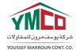 Projects Manager

YMCO
Oct 2012 - Mar 2014 (1 year 6 months)
(Care Centers Riyadh & Jeddah 150 million SAR (Prison), Saudi Aviation Technical Institute 115 million SAR, Almarai Dairy Depots Dammam & Jubail 110 million SAR, College of Tourism Taif 80 Million SAR, Sharbatly Cold Stores Medina & Tabouk 75 Million SAR, SADAFCO RDC 50 Million SAR, DHL Mixed Use Facilities Riyadh & Dammam 50 Million SAR, Total Projects Value 650 Million SAR)
Client Name: Various Clients Responsibilities:
•Projects Management (all disciplines and knowledge areas of Project Management).
•Training and educating team members on PM methodology.
•Procurement Management local and global.
•Design and Built contracts (High- & Low-rise buildings).
•Architectural and interior design.
•Contracts’ Management and Negotiations.
•Intensive projects management plan to maintain company strategic goals.
•Value Engineering Implementations.
•Risk Management. Problem Solving.
•Correcting project Path & improvement of cost and time control.
•Setting out of Company strategically approaches projects.
•Preparing and issuing monthly reports and project analyses.
•Architectural Management at site.
•Supportive Management at site meetings and work progress.
•All responsibilities as commercial section head was carried along.
•Revision of contract details and specifications.
•Locating international Vendors & Manufacturers to supply special materials for different projects.

 Projects Manager

ACE Contracting Establishment
Aug 2011 - Sep 2012 (1 year 2 months)
Siporex Factory new HQ offices, King Khalid Ranch Extension, Khozama Medical Center Extension, Jotun Warehouse Extensions, Day Care Center Extensions, Residential Villas KSA-Qatar)
Client Name: Various Clients Responsibilities:
•Projects Management (all disciplines and knowledge areas of Project Management).
•Erection of Precast Light Weight Concrete Structures.
•Procurement Management & Designs.
•Design and Built contracts (High- & Low-rise buildings).
•Architectural and interior design.
•Contracts’ Management and Negotiations.; Design and Built contracts (15 stories and above).
•Architectural and interior design.

Executive Manager

Brothers Integrated Solutions
Jun 2010 - Jun 2011 (1 year 1 month)
Design and Built contracts (15 stories and above).
•Architectural and interior design.
(Merawi Hospital Consultancy Value 200 K USD, SCIF Hotel Sudan- Finishing 14+, Total Value 350 K USD)
Client Name: Various Clients Responsibilities:
•Supplying and installing Special Building Materials (Fire Exit Doors with Anti Panic Devices, Parliament and Conference Seating, Designing of Conference Halls, Projects Management Decorative finishing etc.).
•Projects Management Consultant.

Projects Manager

Kuwaiti Sudanese Aluminum Company (KUDAL)
Jun 2009 - May 2010 (1 year)
Ministry of Exterior Affairs Consulate Building 700 K USD, SCIF Head Offices 500 K USD, JCP Head Office 350 K USD, Ministry of Awgaf Head Office 350 K USD, Ministry of Justice Head Quarters 1.2 M USD)
Client Name: Various Clients Responsibilities:
•Management strategies & Implementation of managerial plans. Projects Management.
•Contract Management & Negotiations.
•Management of sub-Contractors.
•Coordination between Sub-Contractors, Clients & Consultants.
•Data analyses & time scheduling.
•Introducing New Technologies in the Field to the Local market
Managing 85 employees from different categories (Engineers, Technicians, Foremen, etc.).

Manager of Projects Brothers Integrated Solutions Jan 2009 - May 2009 (5 months)
Client Name: Various Clients, Private residencies Responsibilities:
•Management strategies & Implementation of managerial plans.
•Projects Management.
•Contract Management & Negotiations.
•Management of sub-Contractors.
•Coordination between Sub-Contractors, Clients & Consultants.
•Data analyses & time scheduling.
•Specialized & Conventional Architectural Designs.

Project Procurement Manager/ Projects Architect

Concrete Engineering Company
Aug 2005 - Dec 2008 (3 years 5 months)
Breast Care Hospital, MOP Hotel, Ministry of Mining HQ, University Auditorium projects, Ministry of Defense Auditorium, DAL group HQ Auditorium
Client Name: Various Clients Responsibilities:
•Management of materials procurement for several parallel projects.
•Management of Procurement teams, up to 7 members.
•Revision of specification & Providence of alternatives materials in different construction fields.
•Management of sub-Contractors.
•Liaison works between Sub-Contractors, Clients & Consultants.
•Revision & supportive management in time plans, delivery schedules and cash flow requirements.
•Revision of architectural designs & providence of architectural solutions & alternatives.
•Architectural Management at site.
•Supportive Management at site meetings and work progress.
•All responsibilities as commercial section head was carried along.
•Revision of contract details and specifications.
•Locating international Vendors & Manufacturers to supply special materials for different projects.
•Preparation of CCS & TCS and concluding agreements with different suppliers.
•Management & Tracking of overseas procured materials till final delivery.
•Projects: (Experts & Trainees Center Hotel, Breast Care Center Hospital, Hajj & Omraa Ministry, DAL Excellence Center, High Institute for Banking Studies, GNPOC Petroleum Camps).

Deputy Project Manager

ETA Electric
May 2002 - Jul 2005 (3 years 3 months)
Khartoum International Airport Departure Terminal (new built)
•Managed coordination between the Main Contractor and the Nominated Subcontractors in the Project.
•Supervised and completed all steel structure for the main building.
•Managed all Export Traffic and handling from the export port to site as well as storage setup.
•Facilitated Local Skilled and unskilled labor, tools, equipment, and local components fabrication
•Revisions and updates of architectural & detailed drawings.
•Manpower supervision and time schedule referencing.

Junior Designer / Site Engineer Mahgoub Engineering Company Jan 2000 - Apr 2002 (2 years 4 months)
•Designed and supervised several residential buildings.
•Assisted in designing several commercial buildings and real stat development.
•Supervised Fabrication of Local Finishing Materials
•Supervised the Execution of Khartoum Airport Departure Terminal Finishing (First Stage)

